Explore Azure compute services

Overview of Azure compute services

- Azure Virtual Machines
- Azure Container Instances
- Azure App Service
- Azure Functions (or serverless computing)

Decide when to use Azure Virtual Machines
VMs are an ideal choice when you need:
- Total control over the operating system (OS).
- The ability to run custom software.
- To use custom hosting configurations.

Examples of when to use VMs
During testing and development.
When running applications in the cloud.
When extending your datacenter to the cloud.
During disaster recovery.

Scale VMs in Azure
You can run single VMs for testing, development, or minor tasks. Or you can group VMs together to provide high availability, scalability, and redundancy. No matter what your uptime requirements are, Azure has several features that can meet them. These features include:
- Virtual machine scale sets
- Azure Batch

What are virtual machine scale sets?
Virtual machine scale sets let you create and manage a group of identical, load-balanced VMs. Imagine you're running a website that enables scientists to upload astronomy images that need to be processed. If you duplicated the VM, you'd normally need to configure an additional service to route requests between multiple instances of the website. Virtual machine scale sets could do that work for you.

What is Azure Batch?
Azure Batch enables large-scale parallel and high-performance computing (HPC) batch jobs with the ability to scale to tens, hundreds, or thousands of VMs
When you're ready to run a job, Batch does the following:
- Starts a pool of compute VMs for you.
- Installs applications and staging data.
- Runs jobs with as many tasks as you have.
- Identifies failures.
- Requeues work.
- Scales down the pool as work completes.

Decide when to use Azure App Service

Azure App Service costs
You pay for the Azure compute resources your app uses while it processes requests based on the App Service plan you choose. The App Service plan determines how much hardware is devoted to your host. For example, the plan determines whether it's dedicated or shared hardware and how much memory is reserved for it. There's even a free tier you can use to host small, low-traffic sites.

WebJobs
You can use the WebJobs feature to run a program (.exe, Java, PHP, Python, or Node.js) or script (.cmd, .bat, PowerShell, or Bash) in the same context as a web app, API app, or mobile app. They can be scheduled or run by a trigger. WebJobs are often used to run background tasks as part of your application logic.

What are containers?
Containers are a virtualization environment. Much like running multiple virtual machines on a single physical host, you can run multiple containers on a single physical or virtual host. Unlike virtual machines, you don't manage the operating system for a container. Virtual machines appear to be an instance of an operating system that you can connect to and manage, but containers are lightweight and designed to be created, scaled out, and stopped dynamically. While it's possible to create and deploy virtual machines as application demand increases, containers are designed to allow you to respond to changes on demand. With containers, you can quickly restart in case of a crash or hardware interruption. One of the most popular container engines is Docker, which is supported by Azure.
Azure Container Instances
Azure Container Instances offers the fastest and simplest way to run a container in Azure without having to manage any virtual machines or adopt any additional services. It's a platform as a service (PaaS) offering that allows you to upload your containers, which it runs for you.
Azure Kubernetes Service
The task of automating, managing, and interacting with a large number of containers is known as orchestration. Azure Kubernetes Service is a complete orchestration service for containers with distributed architectures and large volumes of containers.
Serverless computing is the abstraction of servers, infrastructure, and operating systems. With serverless computing, Azure takes care of managing the server infrastructure and the allocation and deallocation of resources based on demand. Infrastructure isn't your responsibility. Scaling and performance are handled automatically. You're billed only for the exact resources you use. There's no need to even reserve capacity.
Serverless computing includes the abstraction of servers, an event-driven scale, and micro-billing:
Abstraction of servers
Event-driven scale
Micro-billing

Azure Functions
When you're concerned only about the code running your service, and not the underlying platform or infrastructure, using Azure Functions is ideal. Functions are commonly used when you need to perform work in response to an event (often via a REST request), timer, or message from another Azure service, and when that work can be completed quickly, within seconds or less.

Azure Logic Apps
Logic apps are similar to functions. Both enable you to trigger logic based on an event. Where functions execute code, logic apps execute workflows that are designed to automate business scenarios and are built from predefined logic blocks.
Every Azure logic app workflow starts with a trigger, which fires when a specific event happens or when newly available data meets specific criteria. Many triggers include basic scheduling capabilities, so developers can specify how regularly their workloads will run. Each time the trigger fires, the Logic Apps engine creates a logic app instance that runs the actions in the workflow. These actions can also include data conversions and flow controls, such as conditional statements, switch statements, loops, and branching.
Functions - Azure Application Insights, Normally stateless, but Durable Functions provide state. , Each activity is an Azure function. Write code for activity functions.
Logic Apps - Azure portal, Log Analytics, Stateful, Large collection of ready-made actions

What is Azure Virtual Desktop?
Azure Virtual Desktop is a desktop and application virtualization service that runs on the cloud. It enables your users to use a cloud-hosted version of Windows from any location. Azure Virtual Desktop works across devices like Windows, Mac, iOS, Android, and Linux. It works with apps that you can use to access remote desktops and apps. You can also use most modern browsers to access Azure Virtual Desktop-hosted experiences.

What are some key features of Azure Virtual Desktop?

Simplified management, Performance management, Multi-session Windows 10 deployment

Manage virtual machines with the Azure CLI

Create a Linux virtual machine
az vm create \
--resource-group [sandbox resource group name] \
--location westus \
--name SampleVM \
--image UbuntuLTS \
--admin-username azureuser \
--generate-ssh-keys \
--verbose

Listing Images

az vm image list --output table

You can get a full list by adding the --all flag to the command. Since the list of images in the Marketplace is very large, it is helpful to filter the list with the --publisher, --sku or –-offer options.

az vm image list --sku Wordpress --output table –all

az vm image list --location eastus --output table

Specify a size during VM creation
az vm create \
--resource-group [sandbox resource group name] \
--name SampleVM2 \
--image UbuntuLTS \
--admin-username azureuser \
--generate-ssh-keys \
--verbose \
--size "Standard_DS2_v2"

az vm list --output table

Get the IP address
az vm list-ip-addresses -n SampleVM -o table

Filter your Azure CLI queries
az vm show \
--resource-group [sandbox resource group name] \
--name SampleVM \
--query "osProfile.adminUsername"

Stop a VM
az vm stop \
--name SampleVM \
--resource-group [sandbox resource group name]

Start a VM

az vm start \
--name SampleVM \
--resource-group [sandbox resource group name]

Choose a compute provisioning solution for your application

Why automate compute provisioning?
It takes a long time to implement an architecture with many servers manually. You need to configure the operating system, install software, configure that software, and apply updates. You also need to do these tasks for each virtual machine. The tasks can become complex. When you have to carry out complex tasks many times, it's easy to make mistakes.
You need some way to automate the deployment of virtual machines to deal with these issues and difficulties. For each virtual machine, such a solution must be able to:
- Configure the virtual machine. For example, in Azure you need to specify an image from Azure Marketplace, a tier, a size, IP addresses, and other values.
- Configure the operating system for the virtual machine. For example, if the operating system includes a firewall, you must be able to set firewall rules that filter traffic.
- Install software. For example, you might need to install a web server or a database server.
- Apply updates. For example, you might need to apply service packs or hotfixes to the operating system and the installed software.

Custom scripts
The custom script extension downloads and runs scripts on Azure virtual machines. This tool is useful for post-deployment configuration, software installation, or any other configuration or management task.
The following custom script extension configuration can be added to an Azure Resource Manager template for a virtual machine. Use the fileUris property to point to your script file.
{
"apiVersion": "2019-06-01",
"type": "Microsoft.Compute/virtualMachines/extensions",
"name": "[concat(variables('virtual machineName'),'/', 'InstallWebServer')]",
"location": "[parameters('location')]",
"dependsOn": [
"[concat('Microsoft.Compute/virtualMachines/',variables('virtual machineName'))]"
],
"properties": {
"publisher": "Microsoft.Compute",
"type": "CustomScriptExtension",
"typeHandlerVersion": "1.7",
"autoUpgradeMinorVersion":true,
"settings": {
"fileUris": [
"https://your-potential-file-location.com/your-script-file.ps1"
],
"commandToExecute": "powershell.exe -ExecutionPolicy Unrestricted -File your-script-file.ps1"
}
}
}
}

Desired State Configuration extensions
Desired State Configuration (DSC) extensions make it possible for you to deal with the configurations on your infrastructure that might need more complex installation procedures, such as reboots. DSC helps you define a state for your machines instead of writing detailed manual instructions on how to achieve that state for each machine. State configurations are relatively easy to read and implement.
The following example defines a DSC extension handler for a virtual machine in an Azure Resource Manager template. The script property points to a configuration script in blob storage.
{
"type": "Microsoft.Compute/virtualMachines/extensions",
"name": "Microsoft.Powershell.DSC",
"apiVersion": "2018-06-30",
"location": "your-region",
"dependsOn": [
"[concat('Microsoft.Compute/virtualMachines/', parameters('virtual machineName'))]"
],
"properties": {
"publisher": "Microsoft.Powershell",
"type": "DSC",
"typeHandlerVersion": "2.77",
"autoUpgradeMinorVersion": true,
"settings": {
"configuration": {
"url": "https://demo.blob.core.windows.net/iisinstall.zip",
"script": "IisInstall.ps1",
"function": "IISInstall"
}
},
"protectedSettings": {
"configurationUrlSasToken": "odLPL/U1p9lvcnp..."
}
}

}

Chef
A Chef server can handle 10,000 nodes (machines) at a time. Chef makes it possible for you to automate the deployment of your infrastructure and fit it into your workflow, whether on-premises or in the cloud.
The following example shows how a knife command can be used to create a virtual machine on Azure. The command simultaneously applies a recipe that installs a web server on the machine.
knife azurerm server create `
--azure-resource-group-name rg-chefdeployment `
--azure-storage-account store `
--azure-vm-name chefvm `
--azure-vm-size 'Standard_DS2_v2' `
--azure-service-location 'eastus' `
--azure-image-reference-offer 'WindowsServer' `
--azure-image-reference-publisher 'MicrosoftWindowsServer' `
--azure-image-reference-sku '2016-Datacenter' `
--azure-image-reference-version 'latest' `
-x myuser `
-P yourPassword `
--tcp-endpoints '80,3389' `
--chef-daemon-interval 1 `
-r "recipe[webserver]"
You can also use the Chef extension to apply recipes to the target machines. The following example defines a Chef extension for a virtual machine in an Azure Resource Manager template. It points to a Chef server by using the chef_server_url property. It points to a recipe to run on the virtual machine to put it in the desired state.
{
"type": "Microsoft.Compute/virtualMachines/extensions",
"name": "[concat(variables('virtual machineName'),'/', variables('virtual machineExtensionName'))]",
"apiVersion": "2015-05-01-preview",
"location": "[parameters('location')]",
"dependsOn": [
"[concat('Microsoft.Compute/virtualMachines/', variables('virtual machineName'))]"
],
"properties": {
"publisher": "Chef.Bootstrap.WindowsAzure",
"type": "LinuxChefClient",
"typeHandlerVersion": "1210.12",
"settings": {
"bootstrap_options": {
"chef_node_name": "chef_node_name",
"chef_server_url": "chef_server_url",
"validation_client_name": "validation_client_name"
},
"runlist": "recipe[your-recipe]",
"validation_key_format": "validation_key_format",
"chef_service_interval": "chef_service_interval",
"bootstrap_version": "bootstrap_version",
"bootstrap_channel": "bootstrap_channel",
"daemon": "service"
},
"protectedSettings": {
"validation_key": "validation_key",
"secret": "secret"
}
}
}
A recipe might look like the one that follows. The recipe installs an IIS web server.
#install IIS on the node.
powershell_script 'Install IIS' do
action :run
code 'add-windowsfeature Web-Server'
end

service 'w3svc' do
action [ :enable, :start ]
end

Terraform
Terraform is an open-source infrastructure-as-code software tool. You can create infrastructures by using Hashicorp Configuration Language (HCL). This language is created by Hashicorp. You can also use JSON. Terraform lets you create relatively easy-to-read script templates that define what type of resources to create, regardless of the cloud service provider.
The following Terraform script example provisions a virtual machine on Azure:
# Configure the Microsoft Azure as a provider
provider "azurerm" {
subscription_id = "xxxxxxx-xxxx-xxxx-xxxx-xxxxxxxxxxxx"
client_id = "xxxxxxx-xxxx-xxxx-xxxx-xxxxxxxxxxxx"
client_secret = "xxxxxxx-xxxx-xxxx-xxxx-xxxxxxxxxxxx"
tenant_id = "xxxxxxx-xxxx-xxxx-xxxx-xxxxxxxxxxxx"
}

# Create a resource group
resource "azurerm_resource_group" "myterraformgroup" {
name = "myResourceGroup"
location = "eastus"

tags = {
environment = "Terraform Demo"
}
}
# Create the virtual machine
resource "azurerm_virtual_machine" "myterraformvirtual machine" {
name = "myvirtual machine"
location = "eastus"
resource_group_name = "${azurerm_resource_group.myterraformgroup.name}"
network_interface_ids = ["${azurerm_network_interface.myterraformnic.id}"]
virtual machine_size = "Standard_DS1_v2"

storage_os_disk {
name = "myOsDisk"
caching = "ReadWrite"
create_option = "FromImage"
managed_disk_type = "Premium_LRS"
}

storage_image_reference {
publisher = "Canonical"
offer = "UbuntuServer"
sku = "16.04.0-LTS"
version = "latest"
}

os_profile {
computer_name = "myvirtual machine"
admin_username = "azureuser"
}

os_profile_linux_config {
disable_password_authentication = true
ssh_keys {
path = "/home/azureuser/.ssh/authorized_keys"
key_data = "ssh-rsa AAAAB3Nz{snip}hwhaa6h"
}
}

boot_diagnostics {
enabled = "true"
storage_uri = "${azurerm_storage_account.mystorageaccount.primary_blob_endpoint}"
}

tags = {
environment = "Terraform Demo"
}
}
To use this script, run the following command by using Terraform:
terraform apply

Azure automation state configuration
Azure automation state configuration is the service you use to make sure that your DSC configurations are managed properly and deployed across your nodes (virtual machines). Azure automation state configuration works with both Azure virtual machines and machines on-premises. Through an intuitive Azure portal process, you can apply configurations to all of your nodes.
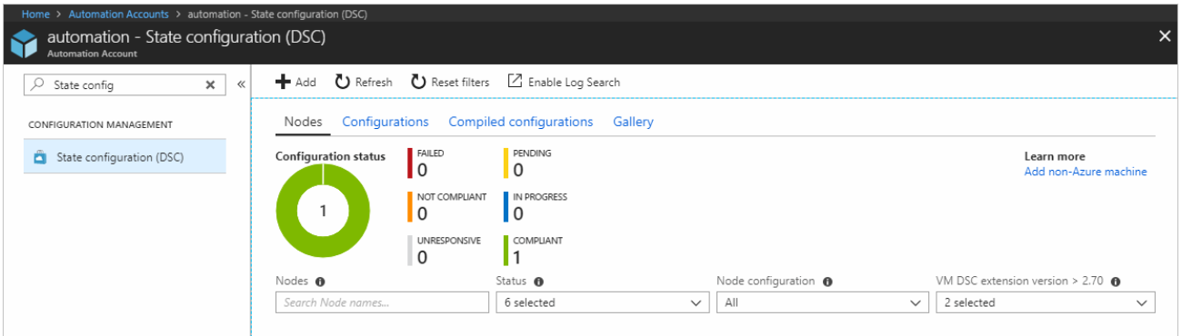

Azure Resource Manager templates
Azure Resource Manager templates are JSON files that you can use to define the Azure resources you want to provision in Azure through object notation. You can define an entire infrastructure this way. They're relatively easy to read and work with, based on your exposure to JSON.
{
"type": "Microsoft.Compute/virtualMachines",
"apiVersion": "2018-10-01",
"name": "[variables('virtual machineName')]",
"location": "[parameters('location')]",
"dependsOn": [
"[resourceId('Microsoft.Storage/storageAccounts/', variables('storageAccountName'))]",
"[resourceId('Microsoft.Network/networkInterfaces/', variables('nicName'))]"
],
"properties": {
"hardwareProfile": {
"virtual machinesize": "Standard_A2"
},
"osProfile": {
"computerName": "[variables('virtual machineName')]",
"adminUsername": "[parameters('adminUsername')]",
"adminPassword": "[parameters('adminPassword')]"
},
"storageProfile": {
"imageReference": {
"publisher": "MicrosoftWindowsServer",
"offer": "WindowsServer",
"sku": "[parameters('windowsOSVersion')]",
"version": "latest"
},…………………………………

Choose a native Azure solution
The right provisioning tools depend on your problem, the size of your infrastructure, and the outcome you want to achieve. Because these criteria vary from network to network, here are a few fundamental metrics that we can use to determine which tool is more suitable to provision compute:
- Ease of setup
- Management
- Interoperability
- Configuration language
- Limitations and drawbacks

Custom script
- Ease of setup. The custom script extension is built into the Azure portal, so setup is easy.
- Management. The management of custom scripts can get tricky as your infrastructure grows and you accumulate different custom scripts for different resources.
- Interoperability. The custom script extension can be added into an Azure Resource Manager template. You can also deploy it through Azure PowerShell or the Azure CLI.
- Configuration language. You can write scripts by using many types of commands. You can use PowerShell and Bash.
- Limitations and drawbacks. Custom scripts aren't suitable if your script needs more than one and a half hours to apply your configuration. Avoid using custom scripts for any configuration that needs reboots.

Solution summary
The custom script extension is good for small configurations after provisioning. It's also good if you need to add or update some applications on a target machine quickly. It's imperative for ad-hoc cross-platform scripting.

Azure Desired State Configuration extensions
- Ease of setup. Desired State Configurations (DSCs) are easy to read, update, and store. Configurations define what state you want to achieve. The author doesn't need to know how that state is reached.
- Management. DSC democratizes configuration management across servers.
- Interoperability. DSCs are used with Azure Automation State Configuration. They can be configured through the Azure portal, Azure PowerShell, or Azure Resource Manager templates.
- Configuration language. Use PowerShell to configure DSC.
- Limitations and drawbacks. You can only use PowerShell to define configurations. If you use DSC without Azure Automation State Configuration, you have to take care of your own orchestration and management.
The company wants to ensure that the virtual machines have the exact same configuration settings. You notice that some of these settings require multiple restarts of each virtual machine.

Solution summary
DSC is easy to read, update, and store. DSC configurations help you declare the state your machines should be in at the point they are provisioned, rather than having instructions that detail how to put the machines in a certain state. Without Azure Automation State Configuration, you have to manage your own DSC configurations and orchestration. DSC can achieve more when it's coupled with Azure Automation State Configuration.

Azure Automation State Configuration
- Ease of setup. Automation State Configuration isn't difficult to set up, but it requires the user to be familiar with the Azure portal.
- Management. The service manages all of the virtual machines for you automatically. Each virtual machine can send you detailed reports about its state, which you can use to draw insights from this data. Automation State Configuration also helps you to manage your DSC configurations more easily.
- Interoperability. Automation State Configuration requires DSC configurations. It works with your Azure virtual machines automatically, and any virtual machines that you have on-premises or on another cloud provider.
- Configuration language. Use PowerShell.
- Limitations and drawbacks. You can only use PowerShell to define configurations.

Solution summary
The Azure Automation State Configuration service is good for automating your DSC configurations, along with the management of machines that need those configurations, and getting centralized reporting back from each machine. You can use DSC without Azure Automation State Configuration, particularly if you want to administer a smaller number of machines. For larger and more complicated scenarios that need orchestration, Azure Automation State Configuration is the solution you need. All of the configurations and features that you need can be pushed to all of the machines, and applied equally, with minimal effort.

Azure Resource Manager templates
- Ease of setup. You can create Resource Manager templates easily. You have many templates available from the GitHub community, which you can use or build upon. Alternatively, you can create your own templates from the Azure portal.
- Management. Managing Resource Manager templates is straightforward because you manage JavaScript Object Notation (JSON) files.
- Interoperability. You can use other tools to provision Resource Manager templates, such as the Azure CLI, the Azure portal, PowerShell, and Terraform.
- Configuration language. Use JSON.
- Limitations and drawbacks. JSON has a strict syntax and grammar, and mistakes can easily render a template invalid. The requirement to know all of the resource providers in Azure and their options can be onerous.

Solution summary
Resource Manager templates can be used for small ad-hoc infrastructures. They're also ideal for deploying larger infrastructures with multiple services along with their dependencies. Resource templates can fit well into developers' workflows. You use the same template to deploy your application repeatedly during every stage of the application lifecycle.

Choose a third-party solution

Chef
- Ease of setup. The Chef server runs on the master machine, and Chef clients run as agents on each of your client machines. You can also use hosted Chef and get started much faster, instead of running your own server.
- Management. The management of Chef can be difficult because it uses a Ruby-based domain-specific language. You might need a Ruby developer to manage the configuration.
- Interoperability. Chef server only works under Linux and Unix, but the Chef client can run on Windows.
- Configuration language. Chef uses a Ruby-based domain-specific language.
- Limitations and drawbacks. The language can take time to learn, especially for developers who aren't familiar with Ruby.

Solution summary
Chef is suitable for large-scale infrastructure deployment and configuration. Chef makes it easy for you to automate the deployment of an entire infrastructure, such as in the workflow of a development team.

Terraform
- Ease of setup. To get started with Terraform, download the version that corresponds with your operating system and install it.
- Management. Terraform's configuration files are designed to be easy to manage.
- Interoperability. Terraform supports Azure, Amazon Web Services, and Google Cloud Platform.
- Configuration language. Terraform uses Hashicorp Configuration Language (HCL). You can also use JSON.
- Limitations and drawbacks. Because Terraform is managed separately from Azure, you might find that you can't provision some types of services or resources.

Solution summary
With Terraform, you can plan the infrastructure as code and see a preview of what the code will create. You can have that code peer reviewed to minimize errors in configuration. Terraform supports infrastructure configurations across different cloud service providers.

Provision a web server
You need to use several tools to provision a web server. Using an Azure Resource Manager template, you can define the environment for your web server. The Resource Manager template can also help you define a desired state configuration (DSC) for your web server. By linking to a DSC extension handler in the Resource Manager template, both the environment and the desired state are applied when you provision the web server. The DSC extension handler helps enforce the DSC state that you defined.
In the following exercise, you'll use a Resource Manager template to provision a virtual machine. The DSC extension handler that's included in the template enforces your state on the virtual machine. You use an Azure storage account to host your DSC configuration file.

d) Deploy Azure infrastructure by using JSON ARM templates

What is infrastructure as code?
Infrastructure as code enables you to describe, through code, the infrastructure that you need for your application.
With infrastructure as code, you can maintain both your application code and everything you need to deploy your application in a central code repository. The advantages to infrastructure as code are:
- Consistent configurations
- Improved scalability
- Faster deployments
- Better traceability

What is an ARM template?
ARM templates allow you to declare what you intend to deploy without having to write the sequence of programming commands to create it. In an ARM template, you specify the resources and the properties for those resources. Then Azure Resource Manager uses that information to deploy the resources in an organized and consistent manner.

Benefits of using ARM templates
ARM templates allow you to automate deployments and use the practice of infrastructure as code (IaC). The template code becomes part of your infrastructure and development projects. Just like application code, you can store the IaC files in a source repository and version it.
ARM templates are idempotent, which means you can deploy the same template many times and get the same resource types in the same state.
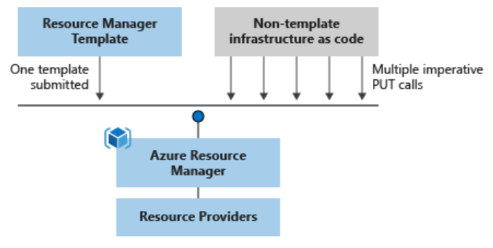

ARM template file structure
When writing an ARM template, you need to understand all the parts that make up the template and what they do. ARM template files are made up of the following elements:
ARM TEMPLATE FILE STRUCTURE
Element | Description
schema | A required section that defines the location of the JSON schema file that describes the structure of JSON data. The version number you use depends on the scope of the deployment and your JSON editor.
contentVersion | A required section that defines the version of your template (such as 1.0.0.0). You can use this value to document significant changes in your template to ensure you're deploying the right template.
apiProfile | An optional section that defines a collection of API versions for resource types. You can use this value to avoid having to specify API versions for each resource in the template.
parameters | An optional section where you define values that are provided during deployment. These values can be provided by a parameter file, by command-line parameters, or in the Azure portal.
variables | An optional section where you define values that are used to simplify template language expressions.
functions | An optional section where you can define user-defined functions that are available within the template. User-defined functions can simplify your template when complicated expressions are used repeatedly in your template.
resources | A required section that defines the actual items you want to deploy or update in a resource group or a subscription.
output | An optional section where you specify the values that will be returned at the end of the deployment.

Deploy an ARM template to Azure
You can deploy an ARM template to Azure in one of the following ways:
- Deploy a local template.
- Deploy a linked template.
- Deploy in a continuous deployment pipeline.
This module focuses on deploying a local ARM template. In future Learn modules, you'll learn how to deploy more complicated infrastructure and how to integrate with Azure Pipelines.
To deploy a local template, you need to have either Azure PowerShell or the Azure CLI installed locally.
{
"$schema": "https://schema.management.azure.com/schemas/2019-04-01/deploymentTemplate.json#",
"contentVersion": "1.0.0.1",
"apiProfile": "",
"parameters": {},
"variables": {},
"functions": [],
"resources": [
{
"type": "Microsoft.Storage/storageAccounts",
"apiVersion": "2019-06-01",
"name": "learntemplatestorage123",
"location": "westus",
"sku": {
"name": "Standard_LRS"
},
"kind": "StorageV2",
"properties": {
"supportsHttpsTrafficOnly": true
}
}
],
"outputs": {}
}

Exercise - Create and deploy an Azure Resource Manager template

Create an ARM template with VS Code
$templateFile = "azuredeploy.json"
$today=Get-Date -Format "MM-dd-yyyy"
$deploymentName="addstorage-"+"$today"
New-AzResourceGroupDeployment `
-Name $deploymentName `
-TemplateFile $templateFile

Add flexibility to your Azure Resource Manager template by using parameters and outputs

"parameters": {
"storageName": {
"type": "string",
"minLength": 3,
"maxLength": 24,
"metadata": {
"description": "The name of the Azure storage resource"
}
}
}
…………"resources": [{
"name": "[parameters('storageName')]",…………
"storageSKU": {
"type": "string",
"defaultValue": "Standard_LRS",
"allowedValues": [
"Standard_LRS",
"Standard_GRS",
"Standard_RAGRS",
"Standard_ZRS",
"Premium_LRS",
"Premium_ZRS",
"Standard_GZRS",
"Standard_RAGZRS"
]
}

Deploy Azure virtual machines from VHD templates

Disk image capabilities for Azure virtual machines

What is an Azure virtual hard disk?
A virtual hard disk is conceptually similar to a physical hard disk. You can use a VHD to host the operating system and run a virtual machine. A VHD can also hold databases and other user-defined folders, files, and data. A VHD can hold anything that you can store on a physical hard disk.
A virtual machine can contain multiple VHDs. Typically, a virtual machine has an operating system VHD on which the operating system is installed. It also has one or more data VHDs that contain the applications and other user-specific data used by the virtual machine.

What is a virtual machine image?
If you consider a VHD to be similar to a physical disk, a virtual machine image is a template from which you can create the VHDs to run a virtual machine. The VHDs for a typical virtual machine image contain a preconfigured version of an operating system.
Azure Marketplace supplies many virtual machine images that you can use as a starting point for your own systems. Examples include:
- Various versions of Windows Server, optionally with SQL Server installed.
- Linux variants with software such as MySQL, MongoDB, Cassandra, or other databases already configured.
For a complete list, visit the Azure Marketplace virtual machine images page.
You can also build your own virtual machine images and VHDs from scratch by using Microsoft Hyper-V. You can then upload these images to Azure so that your virtual machines can use them.
You can extend an existing virtual machine image with your own software. You can then use the image as a basis for deploying additional virtual machines in your organization.

What is a generalized image?
You can create your own custom virtual machine image in one of two ways:
- If you're building an image from scratch by using Hyper-V, you first create a blank virtual disk, and then create a virtual machine with this disk. When you start the virtual machine, you install the operating system and any other additional software from source disks (typically DVDs) and other packages.
- If you're customizing an image from Azure Marketplace, you build a virtual machine by using an existing image. The image provides the operating system and base functionality. You add your own software, operating system updates, and other packages as required. Unit 3 describes this process in more detail.

What is a specialized virtual image?
A specialized virtual image is a copy of a live virtual machine after it has reached a specific state. For example, a specialized image might contain a copy of the configured operating system, software, user accounts, databases, connection information, and other data for your system.
Which tool should you use to prepare a Windows Server image for generalization? – Sysprep
Which command should you use to prepare a Linux image for generalization? – waagent

Generalize a Windows virtual machine
If you're building a Windows image, you use the Sysprep tool to prepare a virtual machine for generalization. Sysprep removes server-specific information from the image, such as the host name, user sign-in information, and logs.
After the virtual machine has been shut down, you must deallocate it
az vm deallocate \
--resource-group <resource group> \
--name <virtual machine name>
Stop-AzVM -ResourceGroupName <resource group> `
-Name <virtual machine name> `
-Force
You can then use the following command for PowerShell or the Azure CLI to generalize the VM.
az vm generalize \
--resource-group <resource group> \
--name <virtual machine name>
Set-AzVM -ResourceGroupName <resource group> `
-Name <virtual machine name> `
-Generalize
If you're building a Linux image, you use the waagent tool to prepare a virtual machine for generalization.

Create an image from a generalized VM

az image create \
--name <image name> \
--resource-group <resource group> \
--source <generalized virtual machine>
az vm create \
--resource-group <resource group> \
--name <new virtual machine name> \
--image <image name> \
--location <location of image>

Create a snapshot of a VHD
A virtual machine image contains an image of every VHD in the virtual machine. You can also create separate snapshot images of a VHD at any time. A snapshot is a read-only copy of a VHD. You can use a snapshot to restore a VHD to the state it was in when the snapshot was taken.

Create a virtual machine from VHD snapshots
Rebuilding a virtual machine from a set of VHD snapshots is a two-step process:
- For each snapshot, create a new managed disk. Specify the snapshot as the source of the managed disk. The simplest way is to use the Azure portal, as shown in the following image
- Create the new virtual machine by using the managed disk. You can do this through PowerShell, the Azure CLI, or the portal.

Build a scalable application with virtual machine scale sets

Features and benefits of virtual machine scale sets

Azure virtual machine scale sets provide a scalable way to run applications on a set of virtual machines (VMs). The VMs in this type of scale set all have the same configuration and run the same applications. As demand grows, the number of VMs running in the scale set increases. As demand slackens, excess VMs can be shut down. Virtual machine scale sets are ideal for scenarios that include compute workloads, big-data workloads, and container workloads.

What is a virtual machine scale set?
Virtual machine scale sets in Azure are designed to allow you to deploy and manage many load-balanced, identical VMs. These machines run with the same configurations. Virtual machine scale sets are intelligent enough to automatically scale up or down the number of VM instances. A scale set can also change the size of VM instances.

A scale set uses a load balancer to distribute requests across the VM instances. It uses a health probe to determine the availability of each instance. The health probe pings the instance. If the instance responds, the scale set knows the instance is still available. If the ping fails or times out, the scale set knows the instance is unavailable and doesn't send requests to it.

Scaling options for scale sets
Scale sets are designed for cost-effectiveness. New VM instances are created only when needed. A scale set can scale VMs either horizontally or vertically.

What is horizontal scaling?
Horizontal scaling is the process of adding or removing several VMs in a scale set.

What is vertical scaling?
Vertical scaling is the process of adding resources such as memory, CPU power, or disk space to VMs.

Scaling a scale set
Virtual machine scale sets address the need to quickly create and manage VMs for a fluctuating workload. You can configure two types of scaling for a scale set:
- Scheduled scaling: You can proactively schedule the scale set to deploy one or N number of additional instances to accommodate a spike in traffic and then scale back down when the spike ends.
- Autoscaling: If the workload is variable and can't always be scheduled, you can use metric-based threshold scaling. Autoscaling horizontally scales out based on node usage. It then scales back in when the resources return to a baseline.

Reducing costs by using low-priority scale sets
A low-priority virtual machine scale set allows you to use Azure compute resources at cost savings of up to 80 percent. The global Azure infrastructure frequently has underused compute resources available. A low-priority scale set provisions VMs through this underused compute capability.
When you use these VMs, keep in mind that they're temporary. Availability depends on size, region, time of day, and so on. These VMs have no SLA
#cloud-config
package_upgrade: true
packages:
- nginx
write_files:
- owner: www-data:www-data
- path: /var/www/html/index.html
content: |
Hello world from Virtual Machine Scale Set !
runcmd:
- service nginx restart
This file contains configuration information to install nginx on the VMs in the scale set.
az vmss create \
--resource-group scalesetrg \
--name webServerScaleSet \
--image UbuntuLTS \
--upgrade-policy-mode automatic \
--custom-data cloud-init.yaml \
--admin-username azureuser \
--generate-ssh-keys

Configure the virtual machine scale set
  - Run the following command to add a health probe to the load balancer
az network lb probe create \
--lb-name webServerScaleSetLB \
--resource-group scalesetrg \
--name webServerHealth \
--port 80 \
--protocol Http \
--path /
2) Run the following command to configure the load balancer to route HTTP traffic to the instances in the scale set
az network lb rule create \
--resource-group scalesetrg \
--name webServerLoadBalancerRuleWeb \
--lb-name webServerScaleSetLB \
--probe-name webServerHealth \
--backend-pool-name webServerScaleSetLBBEPool \
--backend-port 80 \
--frontend-ip-name loadBalancerFrontEnd \
--frontend-port 80 \
--protocol tcp
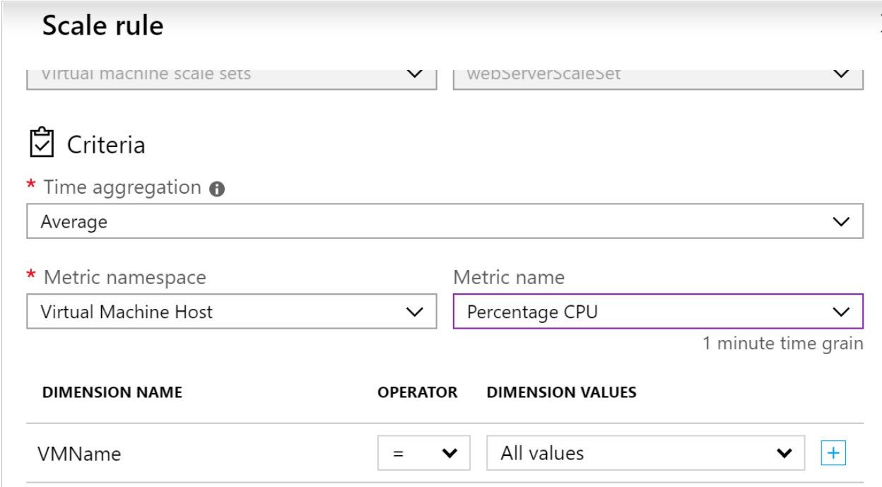
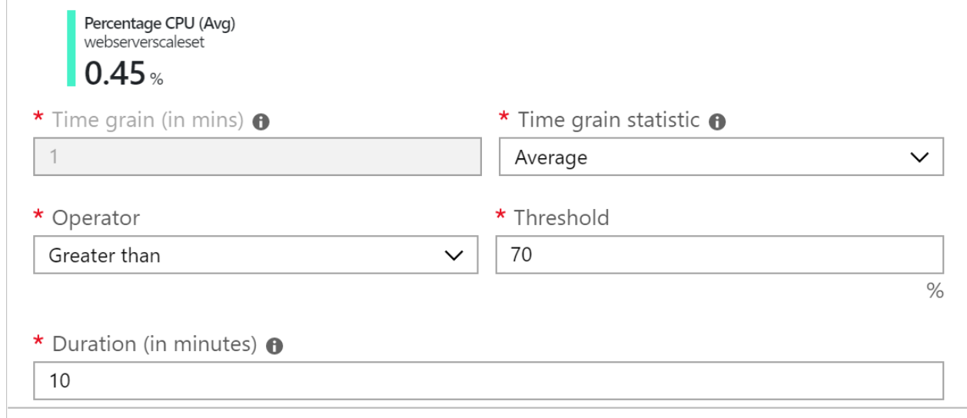
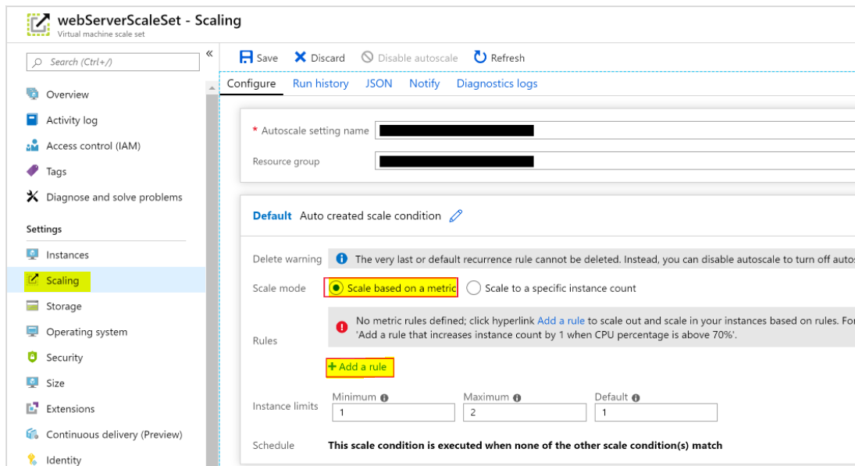

Install an application across a scale set by using a custom script extension

The following example shows a custom script configuration that downloads an application from a repository in GitHub and installs it on a host instance by running a script named custom_application_v1.sh:

# yourConfigV1.json
{
"fileUris": ["https://raw.githubusercontent.com/yourrepo/master/custom_application_v1.sh"],
"commandToExecute": "./custom_application_v1.sh"

}

az vmss extension set \
--publisher Microsoft.Azure.Extensions \
--version 2.0 \
--name CustomScript \
--resource-group myResourceGroup \
--vmss-name yourScaleSet \

--settings @yourConfigV1.json

Choose the best Azure service to automate your business processes

Business processes modeled in software are often called workflows. Azure includes four different technologies that you can use to build and implement workflows that integrate multiple systems:
- Logic Apps
- Microsoft Power Automate
- WebJobs
- Azure Functions

Design-first technologies : Logic Apps , Microsoft Power Automate

Code-first technologies : WebJobs , Azure Functions

Azure WebJobs | Azure Functions
Supported languages | C# if you are using the WebJobs SDK | C#, Java, JavaScript, PowerShell, and so on
Automatic scaling | No | Yes
Development and testing in a browser | No | Yes
Pay-per-use pricing | No | Yes
Integration with Logic Apps | No | Yes
Package managers | NuGet if you are using the WebJobs SDK | NuGet and NPM
Can be part of an App Service application | Yes | Yes (hosted under App Service plan)
Provides close control of JobHost | Yes | No

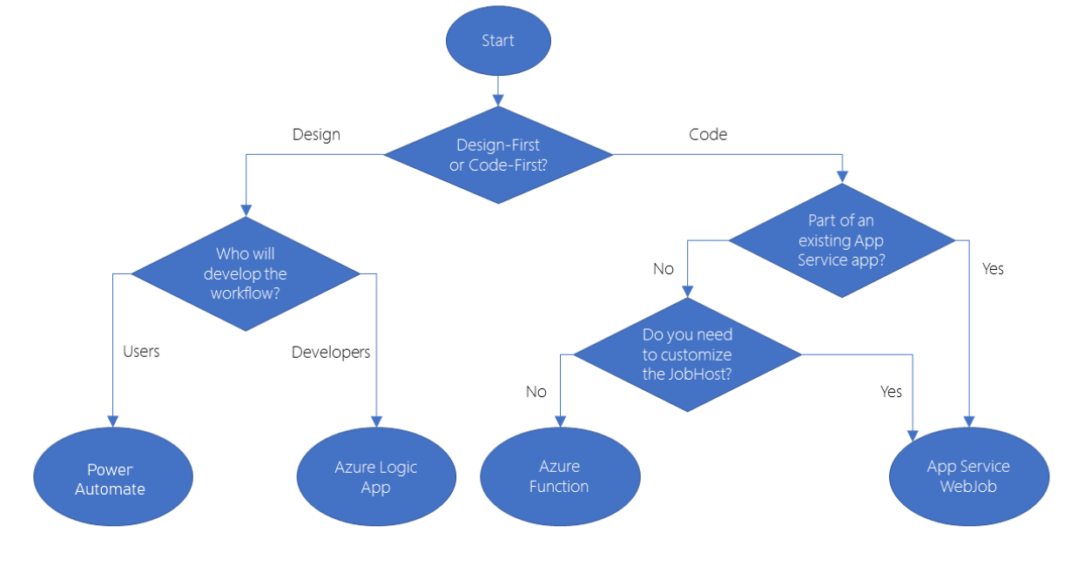

Introduction to high-performance computing (HPC) on Azure

Azure Batch

There are several HPC and batch processing choices available on Azure. You talk with an Azure expert who advises you to focus on three options: Azure Batch, Azure VM HPC Instances, and Microsoft HPC Pack.

What is HPC?
There are many different industries that require very powerful computing resources for specialized tasks. For example:
- In genetic sciences, gene sequencing.
- In oil and gas exploration, reservoir simulations.
- In finance, market modeling.
- In engineering, physical system modeling.
- In meteorology, weather modeling.
These tasks require processors that can carry out instructions extremely fast. It's also helpful to run many processors in parallel, to obtain answers within a practical time duration. On-premises HPC systems have many powerful CPUs and, for graphics-intensive tasks, GPUs. They also require fast disks and high-speed memory.

Azure Batch
Azure Batch is a service for working with large-scale parallel and computationally intensive tasks on Azure. Unlike the other options you'll see in this module, Batch is a managed service. You provide data and applications, and you specify whether to run on Windows or Linux, how many machines to use, and what rules apply to autoscaling. Batch handles provisioning of the compute capacity and optimizes the way the work is done in parallel. You only pay for the underlying compute, networking, and storage you use. The Batch scheduling and management service is free.

Components of Azure Batch
Batch has several components that act together. An Azure Batch Account forms a container for all of the main Batch elements. Within the Batch account, you typically create Batch pools of VMs, which are often called nodes, running either Windows or Linux. You set up Batch jobs that work like logical containers with configurable settings for the real unit of work in Batch, known as Batch tasks.
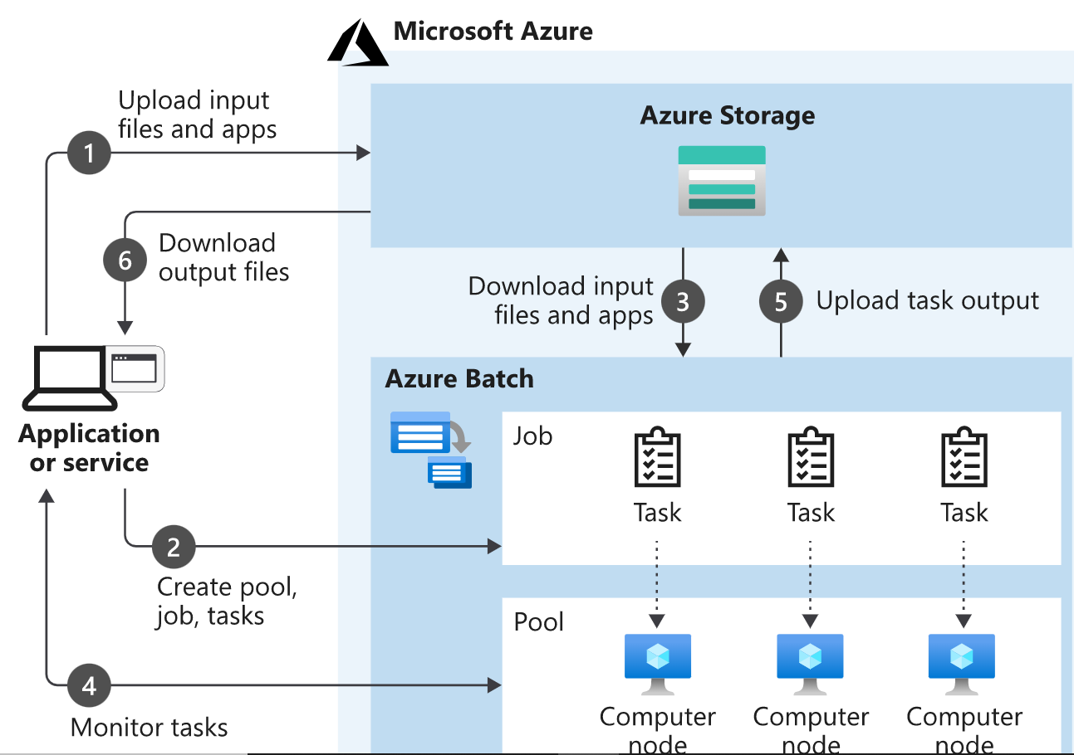

Azure Batch in action
When you create Batch tasks, the scheduling and management engine determines the optimal plan for allocating and scheduling tasks across the specified compute capacity. This plan happens during the initial creation of a Batch pool.
In a series of 100 tasks and 10 nodes, for example, Batch schedules the first 10 tasks onto those 10 nodes. Batch immediately allocates later tasks when nodes finish processing. For spiky workloads, you can configure scaling rules, which Batch also handles automatically. If you provision 100 VMs with no Batch context, you must code these scheduling and work allocation mechanisms by hand.

Azure VM HPC instances

H-series VMs
As the solution architect for the engineering organization, you've already seen how Azure Batch orchestrates hundreds and thousands of nodes working together in parallel.

HB-series VMs
HB-series VMs specifically target applications requiring extreme memory bandwidth, particularly fluid dynamics, explicit finite element analysis, and weather modeling.

HC-series VMs
HC-series VMs are optimized for applications driven by dense computation, such as implicit finite element analysis, reservoir simulation, and computational chemistry.

N-series VMs, NC-series VMs, ND-series VMs

Because H-series VMs use large numbers of cores, you can quickly reach the limit for your subscription. Open a support request to increase this limit.

HB-series VMs are not supported in all Azure regions.

Microsoft HPC Pack

What is HPC Pack?
In researching options for the engineering organization, you've looked at Azure Batch and Azure HPC Instances. But what if you want to have full control of the management and scheduling of your clusters of VMs? What if you have significant investment in on-premises infrastructure in your datacenter?
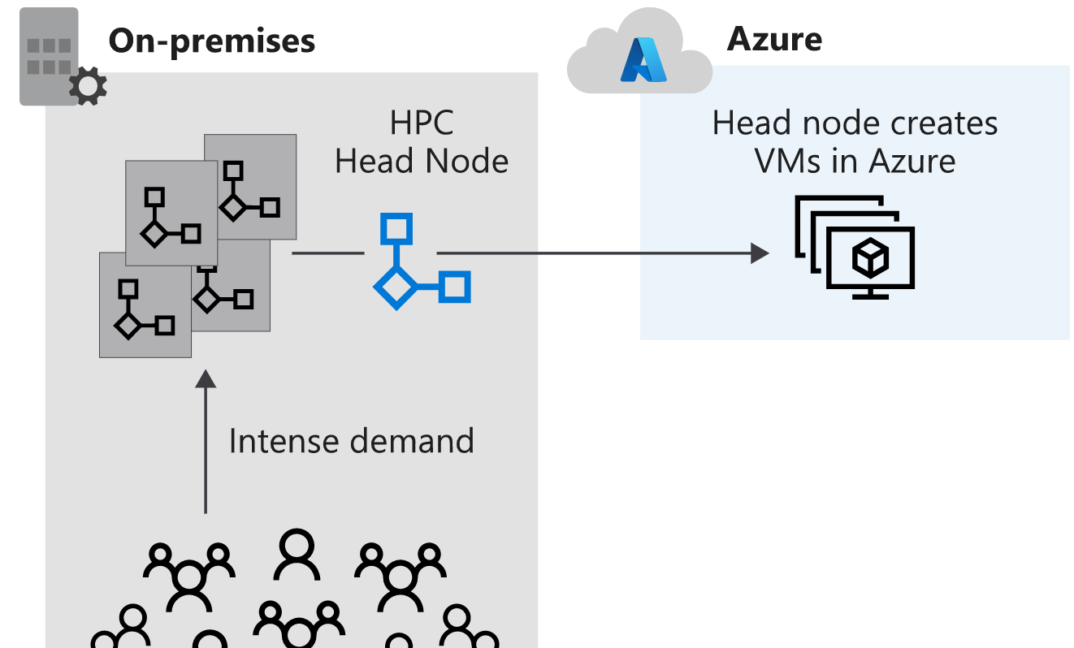

Plan for HPC Pack
Typically, you should prepare for the installation of HPC Pack with a full review of requirements. You need SQL Server and an Active Directory controller. You must also plan a topology. How many head or control nodes should there be, and how many worker nodes? Do you need to expand up to Azure? If so, you pre-provision Azure nodes as part of the cluster. The size of the main machines that make up the control plane (head and control nodes, SQL Server, and Active Directory domain controller) will depend on the projected cluster size.

Run parallel tasks in Azure Batch with the Azure CLI

Create the Azure Batch account
az batch account create \
--name $BATCH_ACCOUNT \
--resource-group $RESOURCE_GROUP \

--location <choose a location from the list above>

az batch pool create \
--id mypool --vm-size Standard_A1_v2 \
--target-dedicated-nodes 3 \
--image canonical:ubuntuserver:16.04-LTS \

--node-agent-sku-id "batch.node.ubuntu 16.04"

az batch job create \
--id myjob \

--pool-id mypool

for i in {1..10}
do
az batch task create \
--task-id mytask$i \
--job-id myjob \
--command-line "/bin/bash -c 'echo \$(printenv | grep \AZ_BATCH_TASK_ID) processed by; echo \$(printenv | grep \AZ_BATCH_NODE_ID)'"
done

Visualize batch jobs with the Batch Explorer

